* **+ 6 V** is recommended for the gate drive.
* It is recommended to start with a turn-on gate resistor in the range between **20Ω to 47Ω**, and then adjust the resistor to achieve the desired slew rate
* GaN enhancement mode HEMT devices have **a positive temperature coefficient on-state resistance** which helps to balance the current.
* However, in practical circuit safety margin must be considered: for GS66508 typical 50-100ns is chosen for dead time.
* For gate, clamping diode will be helpful to protect GaN from spikes.
* Recommend RG(ON)/RG(OFF) ≥ 5-10 ratio for controlling the miller effect
* Ls = 0.05nH

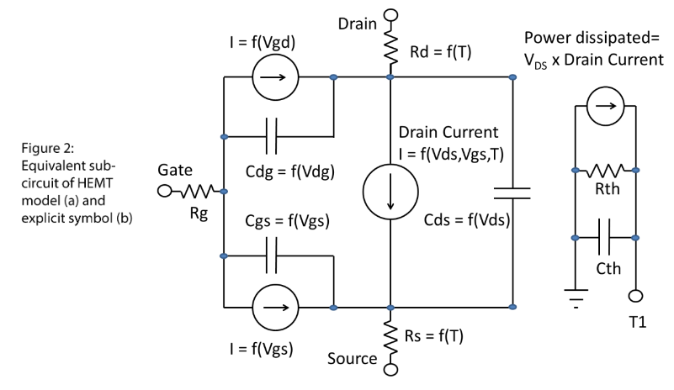

Figure 1: Gate Leakage Currents are also modeled

